**1. On alert.**

**B Match the captions (1-4) with the pictures (a-d)**

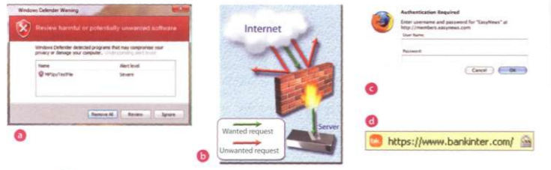

1 d A secure website can be recognized in two ways: the address bar shows the letters https and a dosed padlock or key is displayed at the bottom of the screen.

2 c You have to type your username and password to access a locked computer system.

3 a This program displays a message when it detects spyware and other unwanted software that may compromise your privacy or damage your computer.

4 b Private networks use a software and/or hardware mechanism called a firewall to block unauthorized traffic from the Internet.

**2 Security and privacy on the Internet.**

**C Solve the clues an complete the puzzle**.

1 Users have to enter a to gain access to a network

Password

2 A protects a company Intranet from outside attacks.

Firewall

3 A is a person who uses their computer skills to enter computers and networks illegally.

hacker

4 can infect your files and corrupt your hard drive.

viruses

5 You can download from the Net; this type of software is available free of charge but protected by copyright.

freeware

6 Encoding data so that unauthorized users can't read it is known as

encryption

7 This company uses techniques to decode (or decipher) secret data.

decryption

8 Most is designed to obtain personal information without the user's permission.

spyware

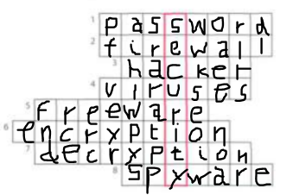

**3 Safety online for children**

**A Listen to an interview with Diana Wilson, a member of the Internet Safety Foundation. Which answers (a or b) best describe what she says?**

**1** Parents should made children aware of

**a** the benefits and risks of the Internet  **b** the risks of the Internet

**2** A web filter program can be used to

**a** prevent access to sites with inappropriate content.

**b** rate web content with labels (similar to the way movies are rated)

**3** If kids spend too much time online of suffer from internet addiction, parents should

**a** stop them using the Internet **b** look for help from specialists.

**B Listen again and complete the interviewer’s notes.**

Risks

Manipulation of children Invasions of (1) privacy

Distribution of indecent or (2) offensive material

Violence and racist (3) propaganda

Solution

There are websites (4) aimed at children

Internet (5) filtering programs let parents block objectionable websites.

Websites should (6) rate their content with a label, from child-friendly to over 18 only.

**4 The history of hacking**

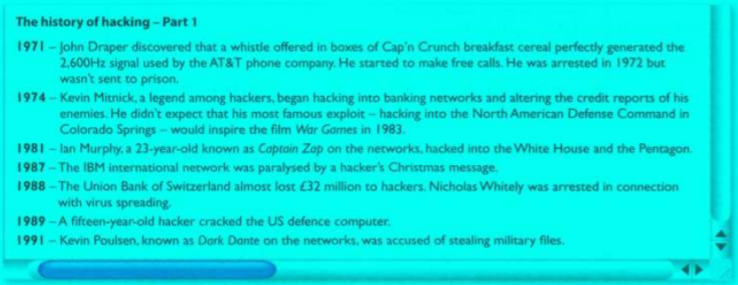

**A Read part 1 of the text and answer these questions.**

**1** Whitch hacking case inspired the film War Games?

Kevin Mitnick hacking into the North American Defense Command in Colorado Springs.

**2** When did Captain Zap hack into Pentagon?

1981

**3** Why was Nicholas Whitely arrested in 1988?

He was arrested in connection with virus spreading after the Union Bank of Switzerland almost lost £32 million to hackers.

**4** How old was the hacker that broke into the US defence computer in 1989?

15

**5 Language work: the past simple**

**A Look at the HELP box and the complete Part 2 of the text with the past simple form of the verbs in the box.**



The history of hacking – Part 2

1992 – David L. Smith (1) was prosecuted for writing for writing the Melissa virus, which was passed in Word files sent via email.

1997 – The German Chaos Computer Club (2) showed on TV how to obtain money from bank accounts.

2000- A Russian hacker (3) attempted to export $100.000 from online music retailer CD Universe. A Canadian hacker (4) launched a massive denial of service attack against websites like Yahoo! An Amazon.

The Iloveyou virus, cleverly disguised as a love letter (5) spread so quickly that email had to be shut down in many companies. The worn (6) overwrote image and sound files with a copy of itself.

2001- The Code Red worm (7) infected tens of thousands of machines.

2006- Hackers (8) stole the credit card details of almost 20.000 AT&T online customers. However, subscribers to its service (9)weren’t affected (not)

 Page 94, ex. 1B, 2B.

- Page 95, ex. 2C.

- Page 96, ex. 3A, 3B, 4A.

- Page 97, ex. 5A.